CS 340 README Template

About the Project/Project Title

Grazioso Salvare Rescue Animal Dashboard
This project is a dashboard created for Grazioso Salvare to help identify dogs that may be good candidates for search-and-rescue training. The dashboard connects to the Austin Animal Center Outcomes data stored in MongoDB and allows the user to filter the data by different rescue types. The dashboard includes an interactive data table, a pie chart showing animal breeds, and a map that displays the location of a selected animal.

Motivation
The purpose of this project was to give Grazioso Salvare an easier way to search through animal shelter data and find dogs that meet the requirements for different types of rescue training. Instead of searching through the database manually, the dashboard allows the user to select Water Rescue, Mountain or Wilderness Rescue, or Disaster or Individual Tracking and see matching animals. The Reset option returns the dashboard to the full unfiltered data set.

Getting Started
This project was developed and tested in the Codio environment using JupyterLab. Before running the dashboard, the Austin Animal Center Outcomes data must be stored in the aac MongoDB database in the animals collection. The aacuser account must also have access to the database. The CRUD Python module, dashboard notebook, and Grazioso Salvare logo must be available in the project files.

To run the dashboard, open ProjectTwoDashboard.ipynb in JupyterLab and run the code cell. The dashboard connects to MongoDB through the AnimalShelter class in CRUD_Python_Module.py. Once the code runs successfully, JupyterDash provides a link that can be opened to view and use the dashboard.

Steps to Reproduce the Project
- Import the Austin Animal Center Outcomes data into the aac MongoDB database and the animals collection.
- Make sure the aacuser account has permission to access the database.
- Place CRUD_Python_Module.py, ProjectTwoDashboard.ipynb, and the Grazioso Salvare logo in the correct project folders.
- Open ProjectTwoDashboard.ipynb in JupyterLab.
- Run the dashboard code cell.
- Open the JupyterDash link after the server starts.
- Test the Reset, Water Rescue, Mountain or Wilderness Rescue, and Disaster or Individual Tracking options.
- Verify that the data table, animal count, pie chart, and map update when the rescue type changes.
- Select an animal in the table and verify that the map popup displays its name, breed, sex, and age.
- Test the CSV export button to make sure the displayed table data can be downloaded.

Installation
The project uses Python, MongoDB, JupyterLab, Dash, JupyterDash, Dash Leaflet, Plotly, pandas, and PyMongo. Codio provided the development environment and most of the required software for this project.

The main Python libraries used by the dashboard include:

- jupyter_dash for running the Dash application in JupyterLab
- dash for the dashboard interface, data table, and interactive components
- dash_leaflet for the geolocation map
- plotly for the pie chart
- pandas for working with the MongoDB data as a DataFrame
- pymongo for connecting the CRUD Python module to MongoDB

If these packages are not already installed in the environment, they can be installed with pip before running the dashboard.

MongoDB was used because it stores the animal records as documents and makes it possible to search the data using specific query conditions. This worked well for filtering animals by breed, sex, and age. The CRUD Python module provides the connection between MongoDB and the dashboard. Dash was used to create the user interface because it allows the data table, filters, charts, and map to work together through callbacks. Plotly was used for the pie chart, and Dash Leaflet was used to display the animal locations on the map.

Usage
The dashboard starts in the Reset state, which displays the full Austin Animal Center Outcomes data set. The user can select one of four radio buttons to change the dashboard:

Water Rescue
Mountain or Wilderness Rescue
Disaster or Individual Tracking
Reset

When a rescue filter is selected, the dashboard runs a MongoDB query based on the required breed, sex, and age ranges for that rescue type. The data table then updates to display the matching animals. The pie chart updates to show the most common breeds in the filtered results, and the map displays the location of the selected animal. Selecting Reset returns the table and charts to the full data set.

The data table displays 10 records at a time and allows the user to sort the columns and select an animal. Selecting an animal updates the map to show its location along with the animal's breed and name.

The dashboard also shows the number of animals that match the selected rescue filter and allows the displayed table data to be exported as a CSV file. Selecting an animal displays its name, breed, sex, and age in the map popup.

Code Example
rescue_queries = {
'Water': {
'animal_type': 'Dog',
'breed': {'$in': [
'Labrador Retriever Mix',
'Chesapeake Bay Retriever',
'Newfoundland'
]},
'sex_upon_outcome': 'Intact Female',
'age_upon_outcome_in_weeks': {
'$gte': 26,
'$lte': 156
}
}
}

query = rescue_queries.get(filter_type, {})
dff = pd.DataFrame.from_records(db.read(query))

This example shows how the rescue queries are stored in a dictionary and selected based on the rescue type chosen by the user. Reset uses an empty query to return all records. The selected query is passed to the read() method in the CRUD module, and the returned records are placed into a pandas DataFrame for use by the dashboard.

Tests
The dashboard was tested by running the Jupyter notebook and checking each of the four filter options. I first used Reset to make sure the full data set loaded correctly. I then tested Water Rescue, Mountain or Wilderness Rescue, and Disaster or Individual Tracking individually.

For each test, I verified that the data table changed to show the correct filtered records, the pie chart updated based on the current data, and the geolocation map continued to display the location of the selected animal. I also tested Reset again to make sure the dashboard returned to the original unfiltered state.

During testing, I also checked the table pagination, column sorting, row selection, and map marker. Screenshots of each dashboard state are included to show that the filters and widgets worked correctly.

Development Process

I started by connecting the dashboard to my CRUD Python module and verifying that the full animal data set could be retrieved from MongoDB. I then added the Grazioso Salvare logo and my name to the dashboard. After that, I created the rescue-type radio buttons and MongoDB queries for each filter. I added pagination, sorting, and row selection to the data table, followed by the pie chart and geolocation map. I tested each part as I added it instead of waiting until the whole dashboard was finished.

Design Decisions

I tried to keep the dashboard easy to use while still providing the information needed to identify rescue candidates. Radio buttons were used because the user only needs to select one rescue category at a time. I organized the MongoDB queries by rescue type so the dashboard can select the correct query without repeating as much code.

The data table uses pagination and sorting to make the large data set easier to work with. I also added a count showing how many animals match the current rescue filter and an option to export the table data to a CSV file. The pie chart is limited to the 10 most common breeds because showing every breed made the chart difficult to read.

The map uses the selected row from the table and displays the animal's name, breed, sex, and age in the marker popup. This allows the user to see more information about an animal without having to search through the entire table again.

Challenges

One of the main challenges was getting the dashboard callbacks and indentation correct. I had several syntax and indentation errors while working on the map callback, and an extra bracket in the table styling callback also caused the program to fail. I worked through these by checking the error line numbers and testing the code again after each correction. I also changed the pie chart to show only the top 10 breeds because displaying every breed made the chart difficult to read. Testing each filter separately helped me make sure the table, chart, and map were all updating correctly.

Screenshots

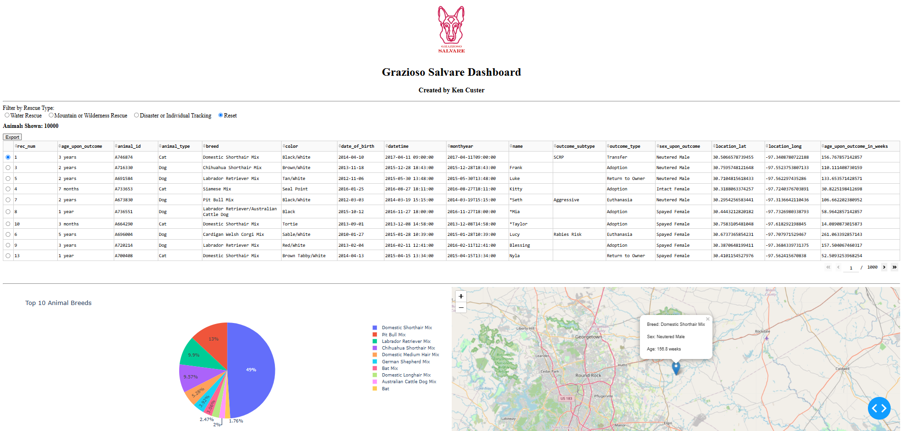
Figure 1. Reset

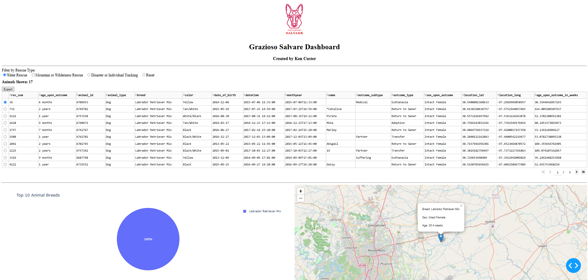
Figure 2. Water Rescue
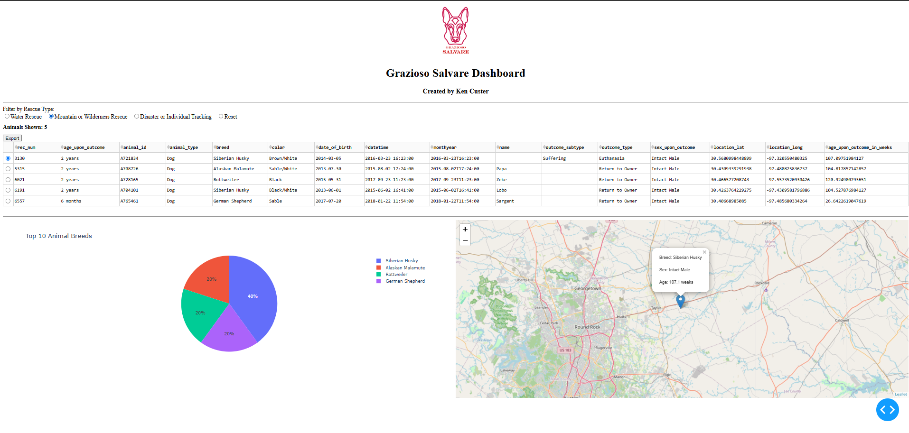

Figure 3. Mountain and Wilderness Rescue

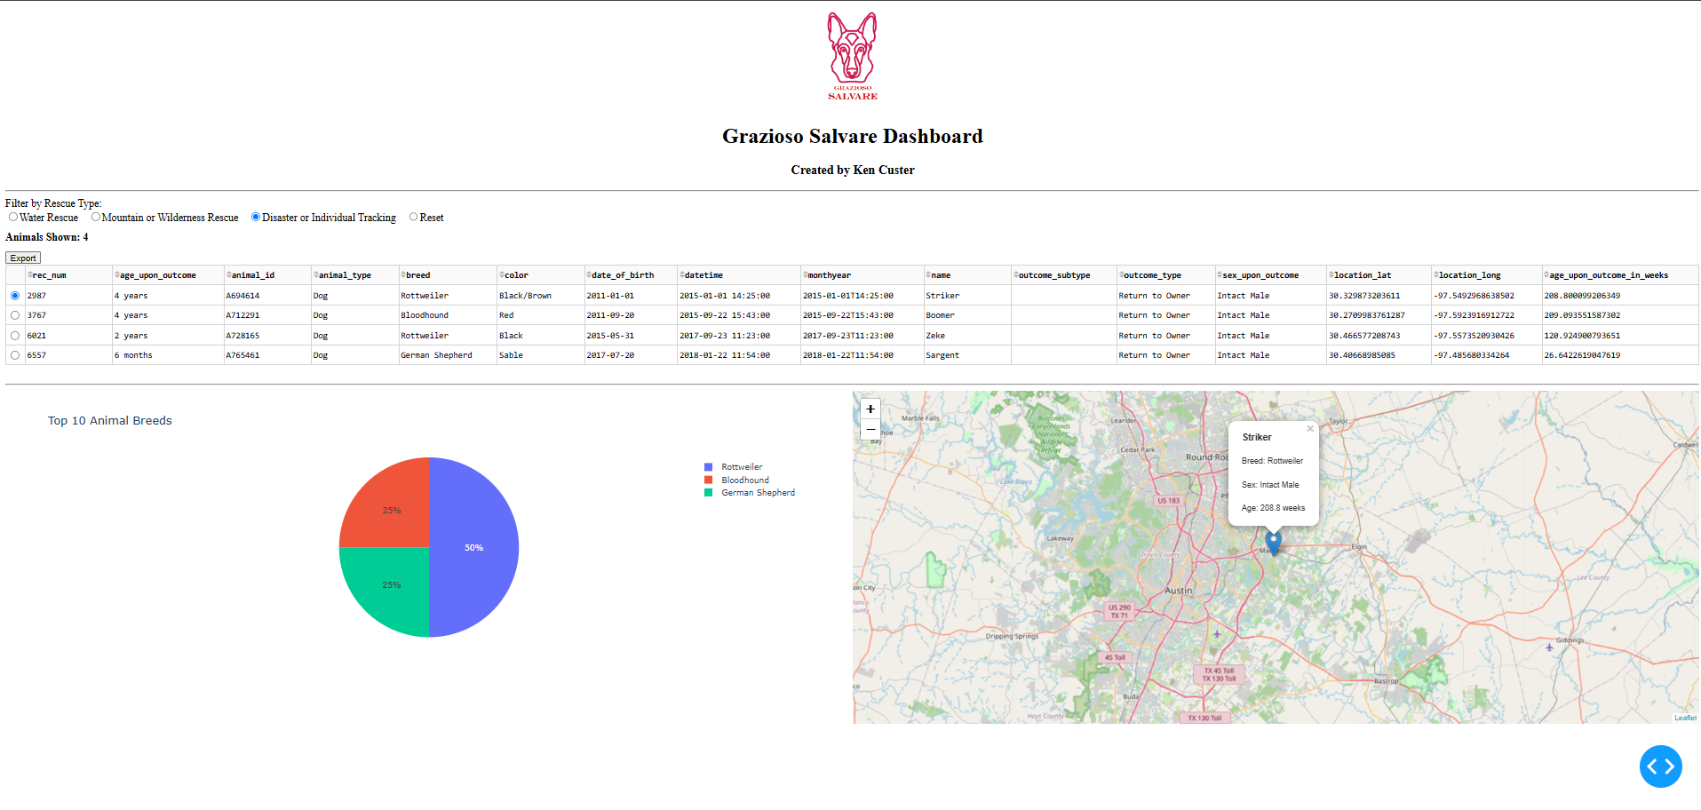
Figure 4. Disaster or Individual Tracking

Contact
Ken Custer

